Asimov Sherlockian-Limericks-The Mysterious Press, 1978 Limited edition number 68-of 250 signed by both author Isaac Asimov and illustrator Gahan Wilson. Sixty limericks, one for each of the sixty tales of the Sherlockian canon. Illustrated with a full color frontispiece by Gahan Wilson. 60 pp plus author information and the limitation page. Fine in fine dust jacket in a fine slipcase. ISBN 089296040X
Id 000196 Price $275 Box One
BookFinder Biblio one at $299.75
Via Libri none found same Biblio
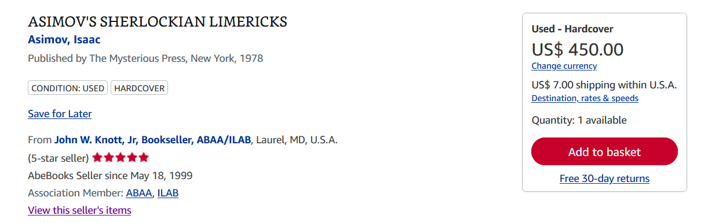
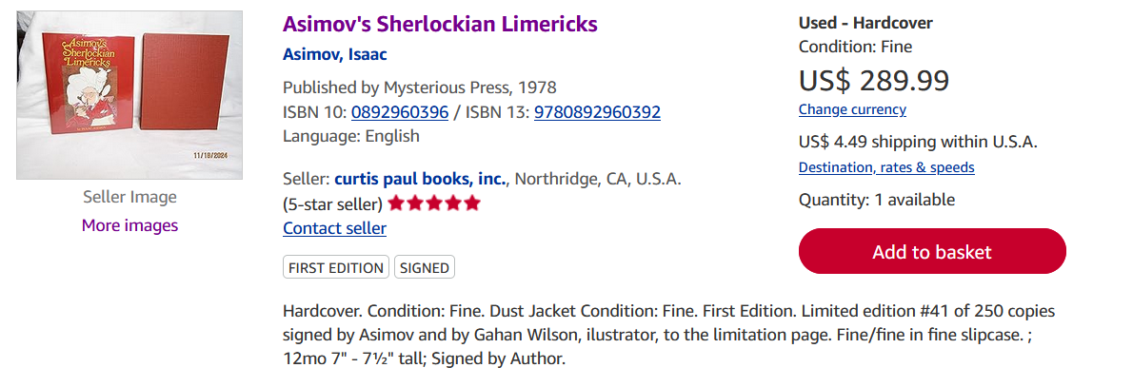
AbeBooks

68 of 250 numbered copies signed by Issac Asimov and Gahan Wilson author and artist. Sixty limericks, one for each of the sixty tales of the Sherlockian canon. A fine copy in fine dust jacket. In a fine slipcase.

